Part 1 (a) - IBM Cloud Registration with Citi email

1. Access the below url - <https://ibm.biz/BdqAbW> or <https://tinyurl.com/y5hprskm>
2. Enter your Citi Email Id and create a new Password

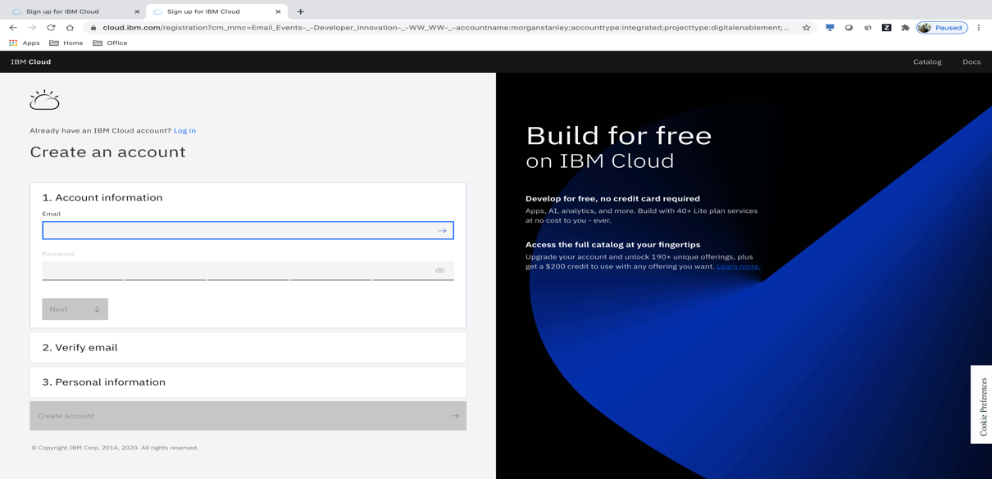

1. Enter 7-digit verification code sent to your email
2. Enter First Name, Last Name & select your Country
3. Uncheck ‘by email’ and ‘by telephone’ options and click on ‘Create Account’
4. This will create a free IBM Cloud account that never expires. Account type will be “Lite”, meaning you will get access to 46 out of 190+ Services.
5. Login to IBM Cloud using your email id and password

Part 1 (b) - IBM Cloud Registration with Personal email

1. Access the below url - <https://ibm.biz/BdqAbW> or <https://tinyurl.com/y5hprskm>
2. Enter your Personal email id and Password

1. Enter 7-digit verification code sent to your email
2. Enter First Name, Last Name & select your Country
3. Uncheck ‘by email’ and ‘by telephone’ options and click on ‘Create Account’
4. This will create a free IBM Cloud account that never expires. Account type will be “Lite”, meaning you will get access to 46 out of 190+ Services.
5. Login to IBM Cloud using your email id and password
6. Click at the top most left corner from your IBM Cloud Dashboard. Select Manage -> Account.

1. Click on Account settings from Left Hand Side menu

1. Click on Edit icon (pencil) against your name

1. Change the Account Name to **Citigroup** and click on Submit

**NOTE:**

* Your IBM Cloud Id (email id that you used for signup) is same as IBM Id
* If you face any difficulties in completing the above steps – Part 1 (a) or Part 1 (b), use Private / Incognito mode of your browser and try all the steps
* If you still face issues, try with your VPN switched off or connect your laptop to your Mobile Wifi
* You can also try the above steps from your Mobile

Part 2 - Deploy a sample app using CI/CD toolchain

(to activate your account)

Deployment of below sample application is required to verify whether the environment is properly set-up

1. Access the following url - <https://ibm.biz/Bdqe5J> or <https://tinyurl.com/yxqrrhjs>

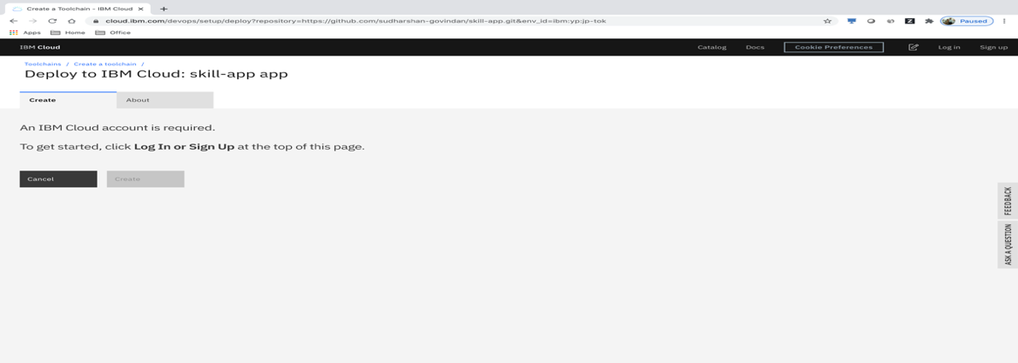

1. Login using the email id used in Part 1 (a) or Part 1 (b)

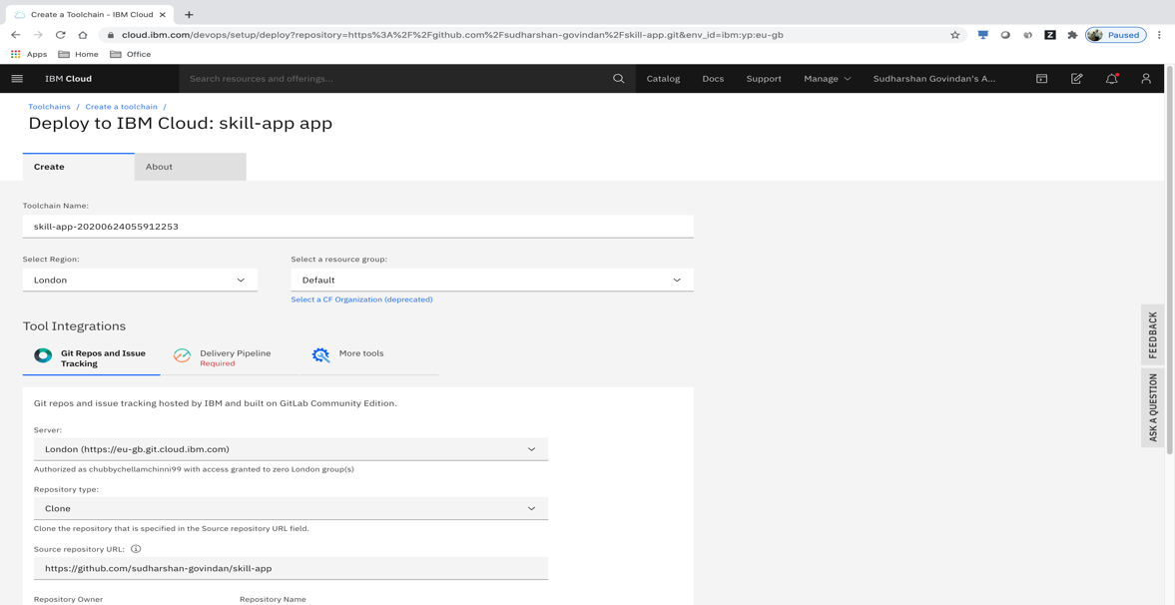

1. Select your Region. To find your default Region, follow the steps given in “Part 4 - How to find your default IBM Cloud Region ?” of this document.
2. Click on ‘Delivery Pipeline’ tab

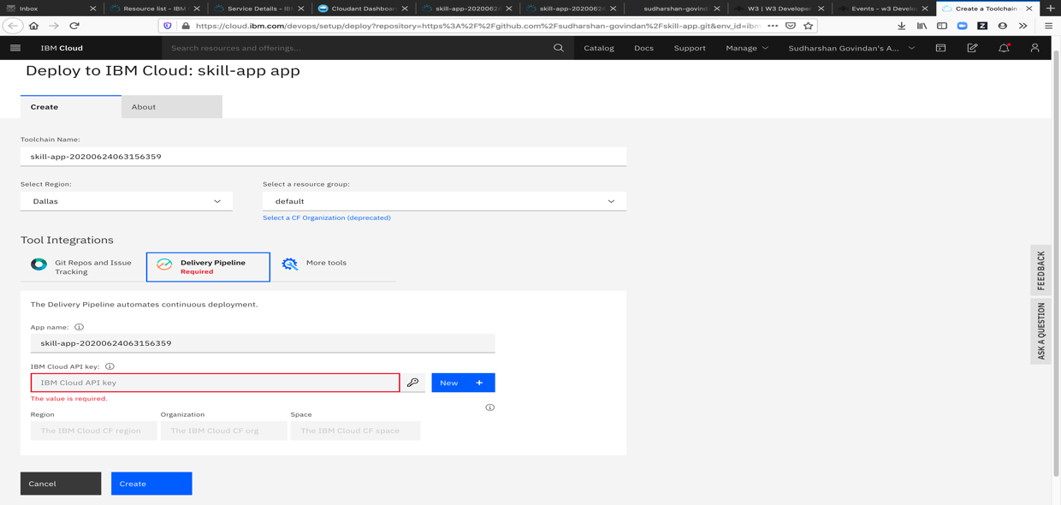

1. Click on ‘New’ to create an API key. Click on ‘OK’.

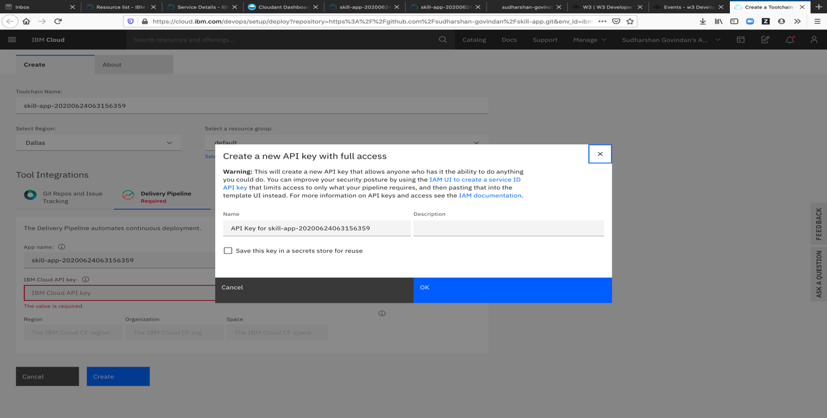

1. Click on ‘Create’

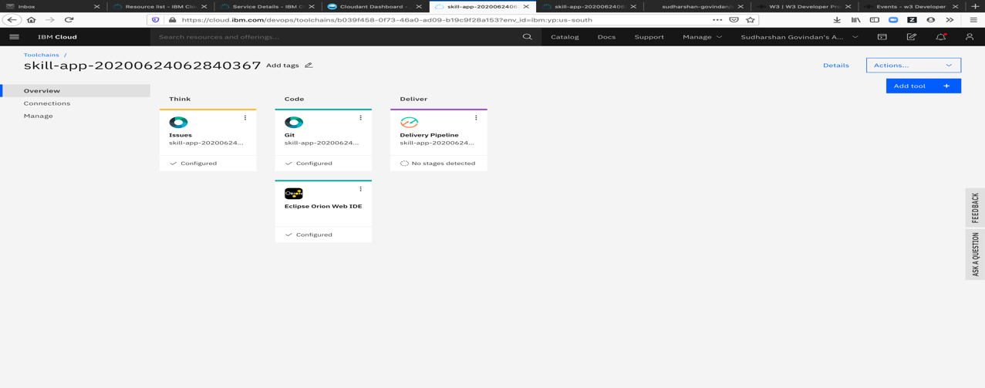

1. Click on ‘Delivery Pipeline’ tab and you should see the following

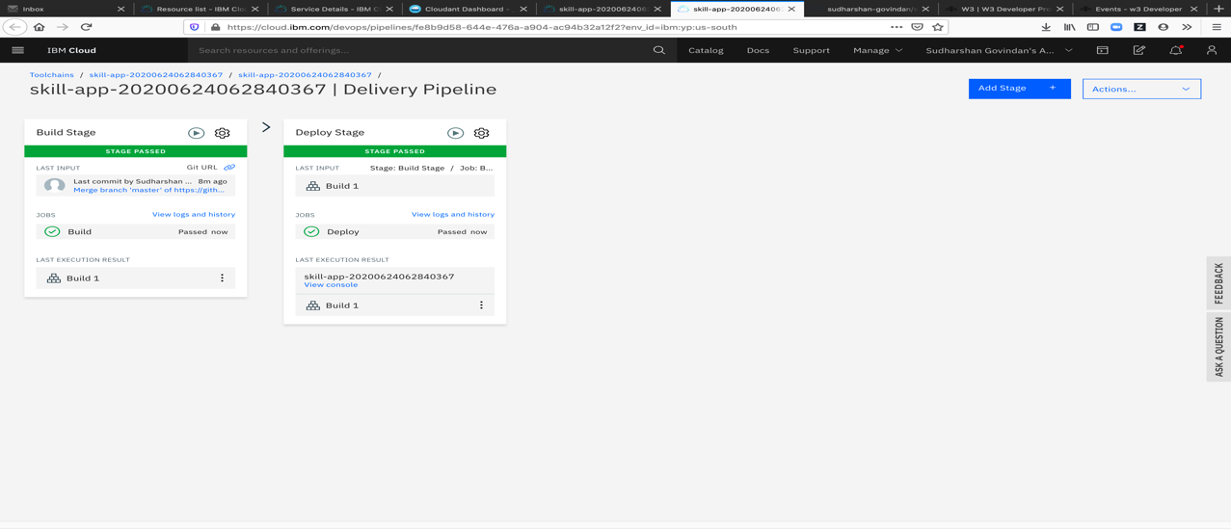

1. If for some reason, the Build or Deploy Stages fail, you can re-run them by clicking on the “play” icon, located at the top right corner of the stage
2. After the Build & Deploy Stages are successful, click on View console link, found at the bottom of Deploy Stage tile. This will open the deployed app’s home page.

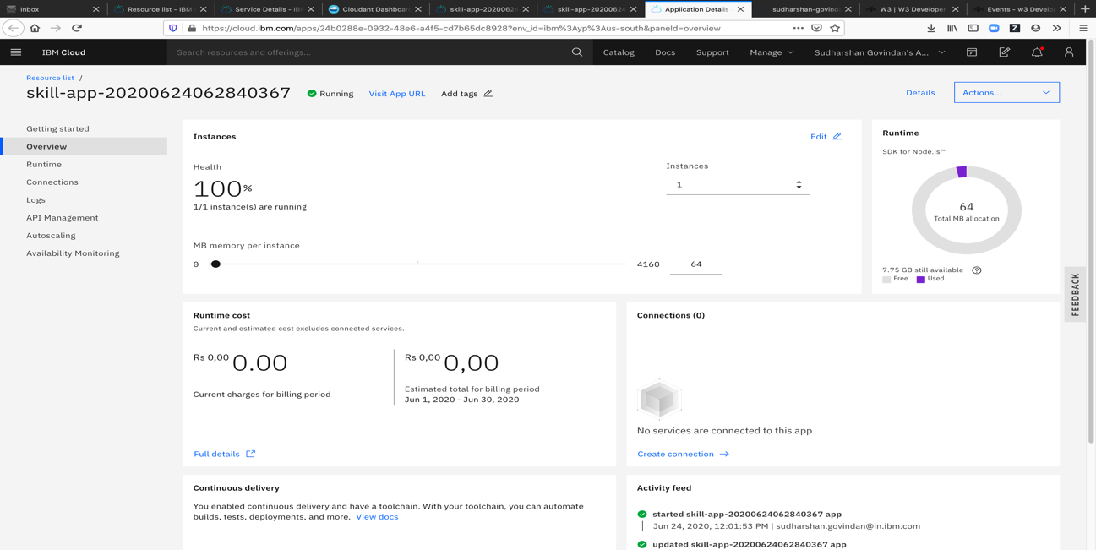

1. Click on ‘Visit App URL’ link at the top and should see the following screen

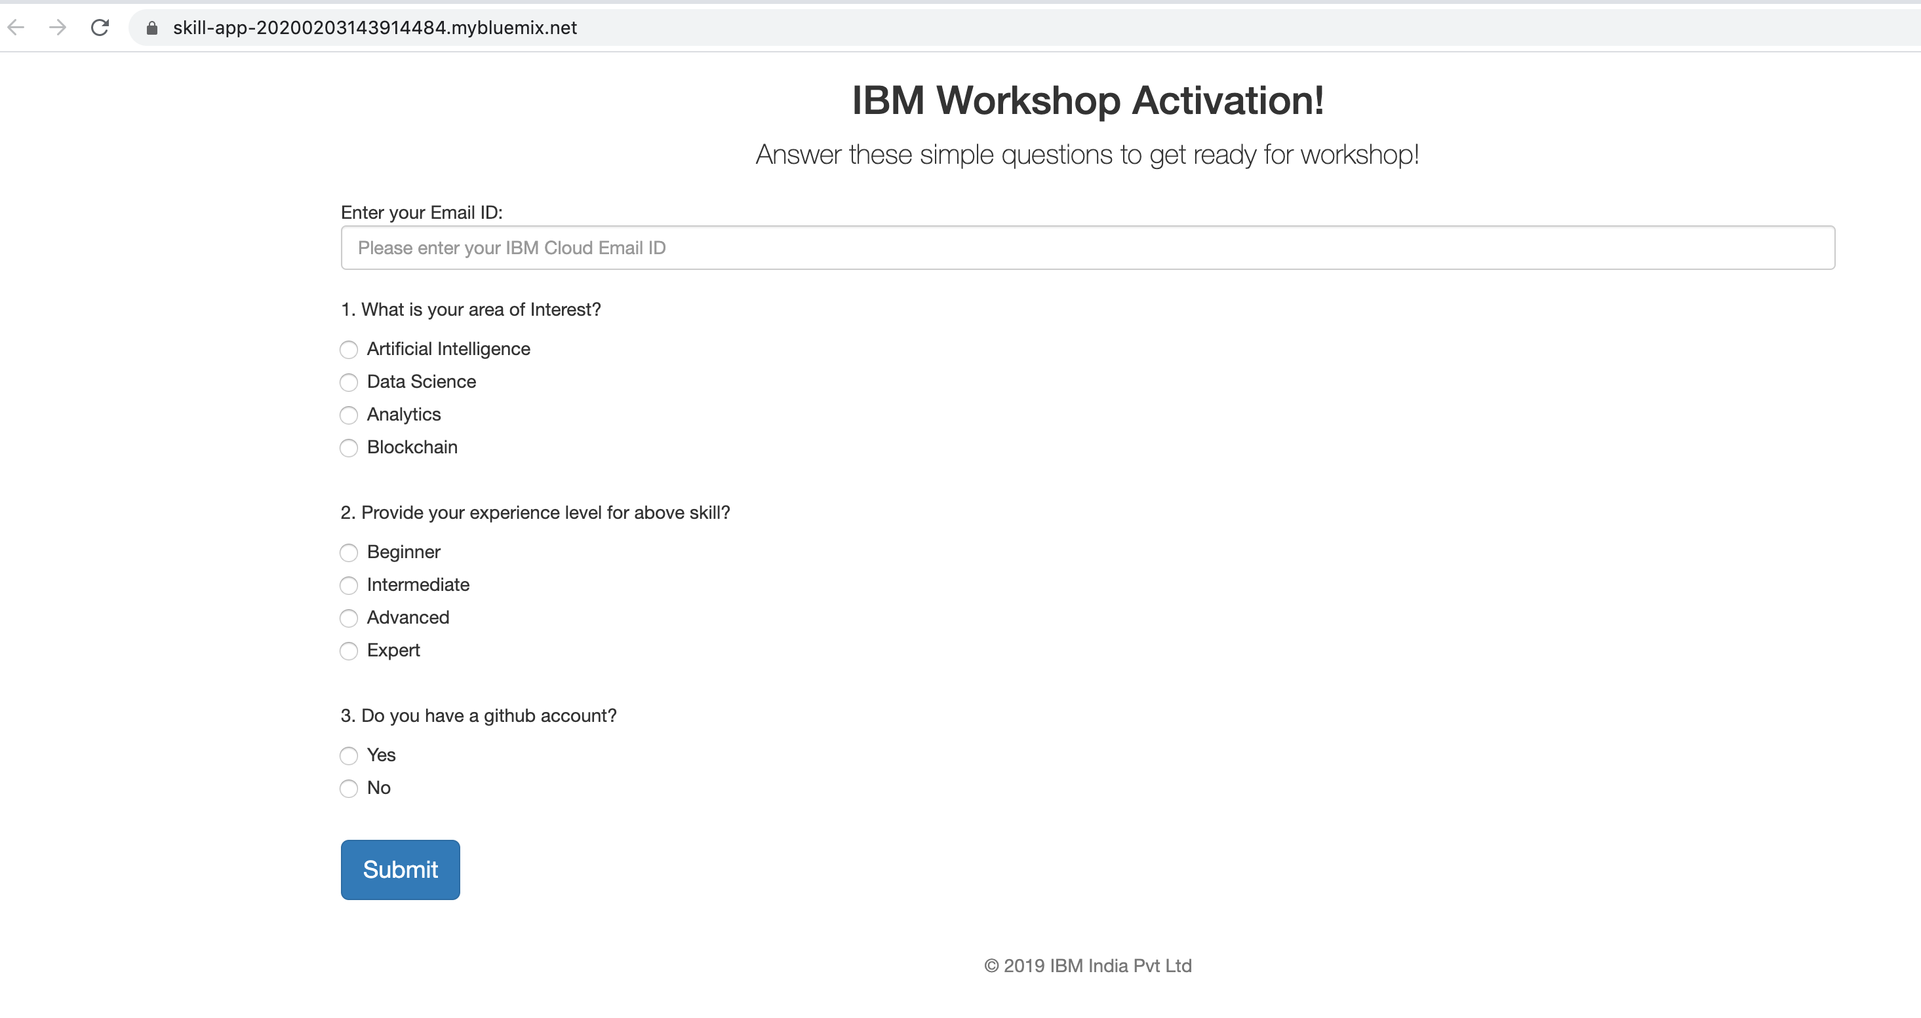

1. Enter the details and click on Submit

Congratulations !!! You have now successfully deployed the app.

Part 3 – Workshop Pre-requisites

1. IBM Cloud account. Signup here - <https://ibm.biz/BdqAbW> or <https://tinyurl.com/y5hprskm>
2. Signup for a free GitHub account, if not already - <https://github.com/>
3. Windows 7 is NOT supported. Minimum supported OS version is Windows 10.
4. Ensure your OS – Windows / Linux / Mac has been run with all the latest updates
5. Make sure you have Administrative Privileges on your machines to download, install & run software
6. Nearly “Open” Network where Open Source software can be downloaded, installed and configured on developers’ machines
7. On a Windows machine, use Power Shell only (in Administrative mode) to run commands. Do NOT use the Command Prompt – *cmd*.
8. Browsers - Firefox, Chrome, Edge & Safari to be on the latest version
9. If *curl* is not installed on your machine, download it from <https://curl.haxx.se/download.html>
   1. Add the *curl* folder path to your machine’s PATH environment variable so it is available from any location from command line
   2. Check if *curl* is configured properly by running *curl --help* from command line
   3. It should show the help menu
10. IBM Cloud CLI bundle - <https://cloud.ibm.com/docs/cli?topic=cloud-cli-ibmcloud-cli>

This will install stand-alone IBM Cloud CLI plus the following tools:

* Homebrew (Mac only)
* Git
* Docker
* Helm
* kubectl
* curl (Linux only)
* IBM Cloud Functions plug-in
* IBM Cloud Object Storage plug-in
* IBM Cloud Container Registry plug-in
* IBM Cloud Kubernetes Service plug-in

Part 4 - How to find your default IBM Cloud Region ?

1. Login to your IBM Cloud account
2. From the top menu, click on Manage -> Account

1. Click on Cloud Foundry orgs from LHS menu

1. Your IBM Cloud User Id (Email Id) is your Cloud Foundry Org name. Click on the link.

1. Your default Cloud Foundry Space is **dev** and note down the Region. This is your default IBM Cloud Region.

1. In the above case, it is United Kingdom (London, eu-gb)
2. For IBM Cloud Lite accounts, there will be 1 Cloud Foundry Org (your login email id) and 1 Cloud Foundry Space (dev)
3. All the Apps have to be created / deployed to your default Region only. Do NOT create in any other Region.
4. If you have a Paid IBM Cloud account, you can create in multiple Regions and can have many Cloud Foundry Orgs and Spaces
5. If you are logging in to your IBM Cloud account using Command Line Interface (CLI), make sure you “target” your Cloud Foundry Org and Space correctly. More details here - <https://cloud.ibm.com/docs/cli?topic=cli-getting-started>

Part 5 - How to apply Promo Code to convert Lite to Trial account ?

1. Apply the promo-code / feature-code assigned to you to create a Free Kubernetes cluster on IBM Kubernetes Service (IKS). You CANNOT create a Free cluster on Red Hat OpenShift with promo code !
2. Login to your IBM Cloud
3. Click on Manage -> Account

1. Click on Account Settings

1. Scroll down to “Subscription and feature codes” section and click on Apply code

1. Enter the promo code and click on Apply. Make sure there are no whitespaces in the text field.

1. Click on Close

1. You can see that your Lite account is converted a Trial account, valid for 90 or 120 days

1. Log off from your account and log back in
2. To create a Free Kubernetes Cluster from IKS, see the steps below

**Create a Free Kubernetes Cluster on IKS**

1. Log in to IBM Cloud
2. Click on Create Resource at the top right corner

1. Click on Services -> Containers from left side menu

1. Click on Kubernetes Service and select Free cluster from plan. Leave the default values as they are and click on Create from bottom right corner.

1. It will take 15 to 20 minutes to create the cluster

1. Click on Overview from left side menu. You should see 1 Worker Node successfully created with 100% Normal status.

